**Answers**

**Part 1**

**Q1)**

**ER Diagram:**

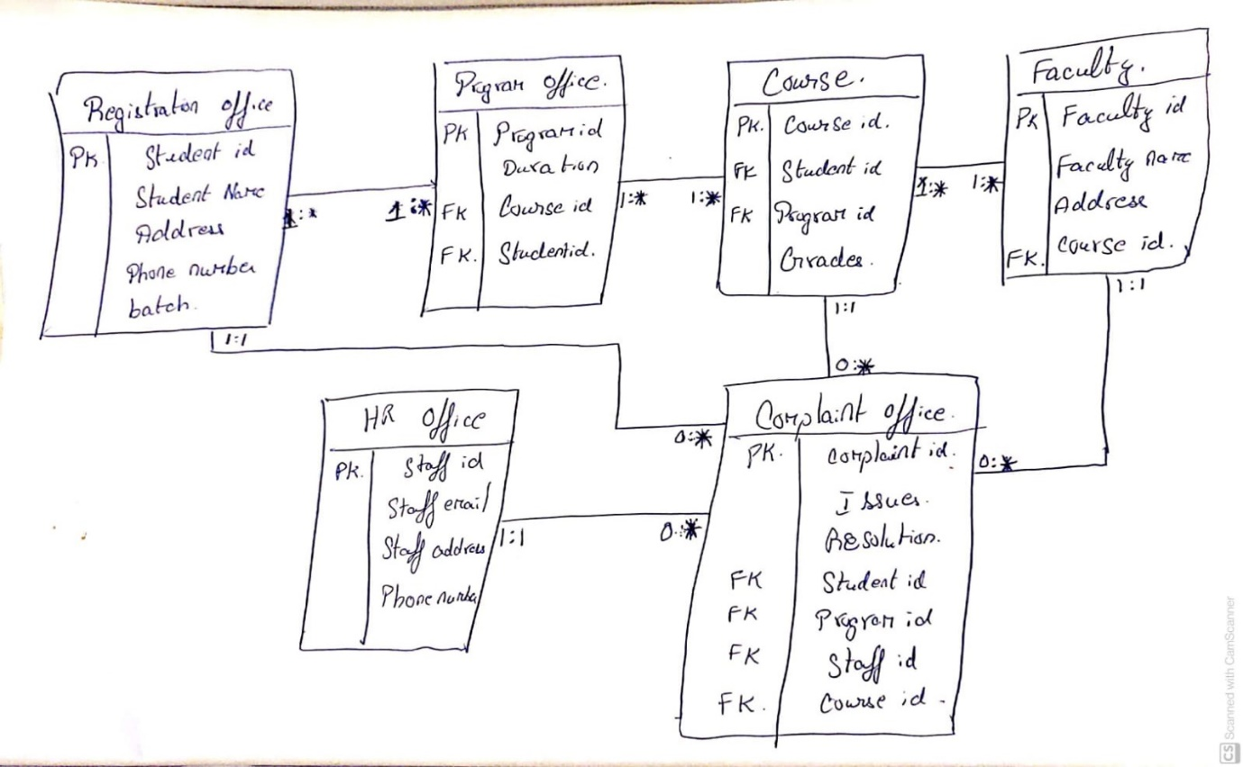

Created a Database “University” with the following Entities:

1)**Registration Office**: In a university we have Registration Office where it contains all the information about the students (Student Id, Student Name, Address, Phone Number, Batch).

Student Id is the Primary Key.

2)**Program Office**: It contains the Program id, Duration of the program, Course id, student id.

Program id is the Primary Key.

Course id and Student Id are the Foreign Keys.

3)**Course**: It contains course id, program id, student id, grades for the subjects.

Course id is the primary key.

Student id and program id is the foreign key.

4)**Faculty**: Every course has a faculty or professor for the teaching. It contains Faculty id, faculty name,faculty address, course id.

Faculty id is the primary key.

Course id is the foreign key.

5)**Complaint Office**: There is office which is responsible for the complaints about the staff, faculties, course etc.

It contains complaint id, issue, resolution, program id, course id, student id, staff id.

Complaint id is the primary Key.

Program id, course id, student id, staff id are the foreign Keys.

6)**HR office**: It contains Staff id, Staff email, staff address, phone Number.

Staff id is the primary key.

**Relationships:**

Registration office and Program office: One student can enrol in many programs and a program will have many students.

Program office and Course: One program has many courses and a course can be tagged to many programs.

Course and faculty: One course can have many faculties or professors and one professor can be tagged to different courses.

Course and Complaint office: Zero or many complaints can be filed from course and complaint office has at least one complaint case from course.

Faculty and complaint office: Zero or many complaints can be filed from Faculty and complaint office has at least one complaint case from Faculty.

Complaint office and HR office: Zero or many complaints can be filed from HR office and complaint office has at least one complaint case from HR office.

Complaint office and Registration office: Zero or many complaints can be filed from Registration office and complaint office has at least one complaint case from Registration office.

I would consider this is the best database for the university purpose because every university has the most similar database like for the student data’s we have the registration office file, for the faculty data’s we have the faculty file, the program and course files will have the academic files and we have complaints database files for all the complaints raised by the students or staff or faculties in the university.

**Q2)**

**Code:**

**#Creating Database University:**

create database University;

Use University;

#**Creating entity(table) registration office from the ER diagram:**

create table registration_Office

(student_id int NOT NULL, student_Name varchar(50), address varchar(80),Phone_no varchar(50),Batch int,primary key(student_id))

#**Creating entity(table) Program office from the ER diagram:**

create Table program_office

(program_id int NOT NULL,Duration Int,student_id int NOT NULL,course_id int NOT NULL,

primary key (program_id),

foreign key(student_id) references registration_office(student_id),

foreign key(course_id)references Course(course_id))

**# Creating entity(table) Course from the ER diagram:**

Create Table Course

(course_id int NOT NULL,student_id int NOT NULL,program_id int NOT NULL,primary key(course_id),

foreign key(student_id) references registration_Office(student_id),grades int,

foreign key(program_id) references program_office(program_id))

**# Creating entity(table) Faculty from the ER diagram:**

Create Table Faculty

(faculty_id int NOT NULL,faculty_name varchar(50),address varchar(80),course_id INT NOT NULL,

primary key(faculty_id),

foreign key(course_id) references Course(course_id))

**# Creating entity(table) Complaint office from the ER diagram:**

Create table Complaint_office

(complaint_id int NOT NULL,Issue varchar(80),Resolution varchar(80),student_id INT NOT NULL,

program_id int NOT NULL,course_id int not null,staff_id int not null,primary key(complaint_id),

foreign key(student_id) references registration_Office(student_id),

foreign key(program_id) references program_office(program_id),

foreign key(course_id) references Course(course_id),

foreign key(staff_id) references HR_office(staff_id))

**# Creating entity(table) HR office from the ER diagram:**

create table HR_office

(staff_id int primary key NOT NULL,staff_name varchar(50),staff_address varchar(80),phone_no int)

**# Inserting 5 rows of dummy data**  **in the table Registration office:**

insert into registration_office(student_id,student_Name,address,Phone_no,Batch) values (001,'Mike','Dumcondra 12',98412383,2);

insert into registration_office(student_id,student_Name,address,Phone_no,Batch) values (003,'jack','Dublin 12',84342383,1);

insert into registration_office(student_id,student_Name,address,Phone_no,Batch) values (002,'Mathew','london 12',54312383,2);

insert into registration_office(student_id,student_Name,address,Phone_no,Batch) values (003,'jerry','chennai 12',96512383,1);

insert into registration_office(student_id,student_Name,address,Phone_no,Batch) values (030,'tom','delhi 12',98412344,1);

**#Output of the table Registration office:**

select * from registration_office;

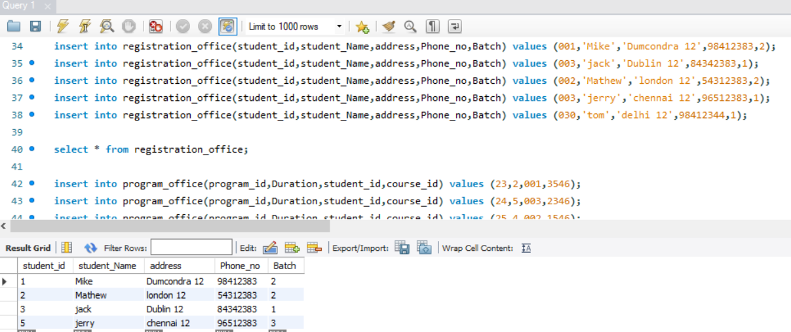

**# Inserting 5 rows of dummy data**  **in the table Program office:**

insert into program_office(program_id,Duration,student_id,course_id) values (23,2,001,3546);

insert into program_office(program_id,Duration,student_id,course_id) values (24,5,003,2346);

insert into program_office(program_id,Duration,student_id,course_id) values (25,4,002,1546);

insert into program_office(program_id,Duration,student_id,course_id) values (26,3,005,6546);

insert into program_office(program_id,Duration,student_id,course_id) values (27,1,001,5546);

**#Output of the table Program office:**

select * from program_office;

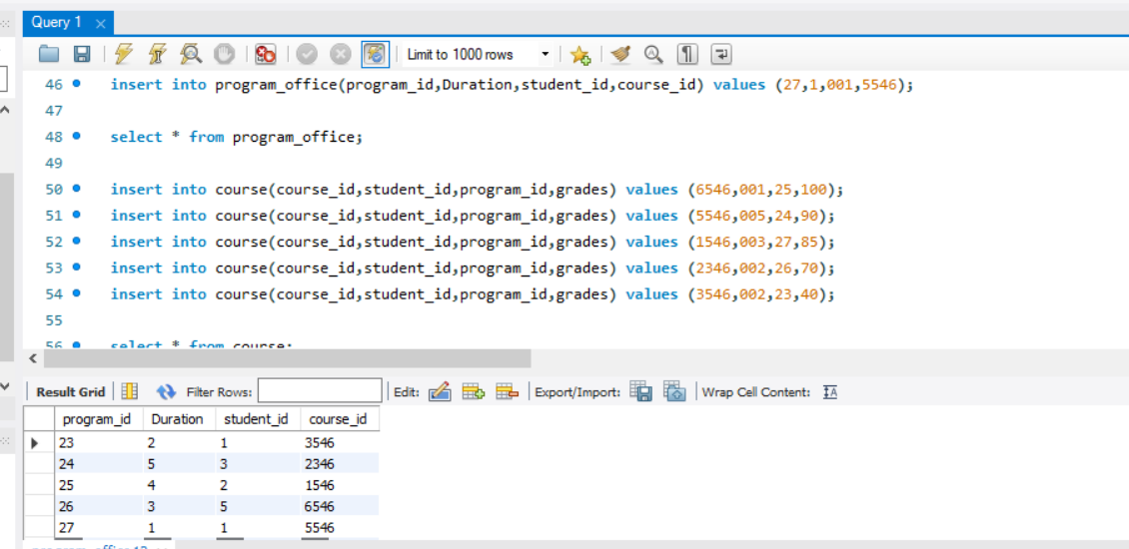

**# Inserting 5 rows of dummy data**  **in the table Course:**

insert into course(course_id,student_id,program_id,grades) values (6546,001,25,100);

insert into course(course_id,student_id,program_id,grades) values (5546,005,24,90);

insert into course(course_id,student_id,program_id,grades) values (1546,003,27,85);

insert into course(course_id,student_id,program_id,grades) values (2346,002,26,70);

insert into course(course_id,student_id,program_id,grades) values (3546,002,23,40);

**#Output of the table Program office:**

select * from course;

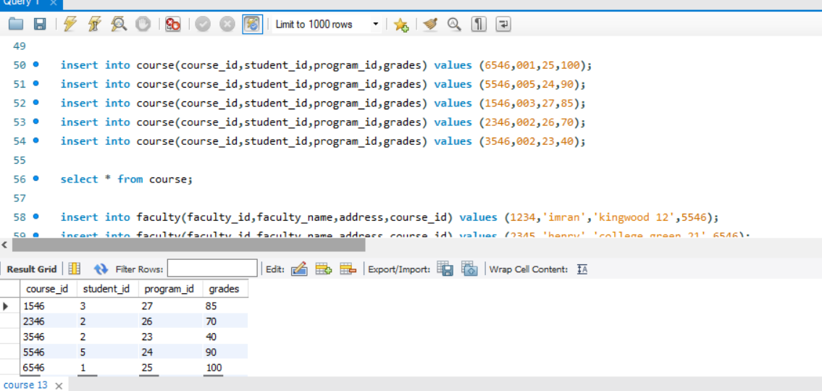

**# Inserting 5 rows of dummy data**  **in the table Faculty:**

insert into faculty(faculty_id,faculty_name,address,course_id) values (1234,'imran','kingwood 12',5546);

insert into faculty(faculty_id,faculty_name,address,course_id) values (2345,'henry','college green 21',6546);

insert into faculty(faculty_id,faculty_name,address,course_id) values (5432,'mark','tallaght 34',1546);

insert into faculty(faculty_id,faculty_name,address,course_id) values (1243,'akif','bihar 54',2346);

insert into faculty(faculty_id,faculty_name,address,course_id) values (2341,'ali','kerala 67',5546);

**#Output of the table Faculty:**

select * from faculty;

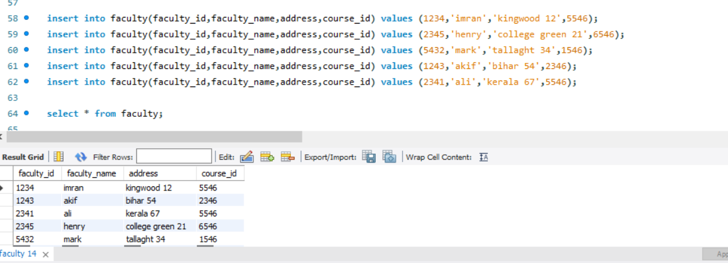

**# Inserting 5 rows of dummy data**  **in the table Complaint office:**

insert into complaint_office(complaint_id,issue,resolution,student_id,program_id,course_id,staff_id) values (92123,'System issue','Yet to check',001,25,6546,70);

insert into complaint_office(complaint_id,issue,resolution,student_id,program_id,course_id,staff_id) values (32123,'data issue','work in progress',003,26,5546,71);

insert into complaint_office(complaint_id,issue,resolution,student_id,program_id,course_id,staff_id) values (22123,'student issue','Yet to check',002,25,6546,72);

insert into complaint_office(complaint_id,issue,resolution,student_id,program_id,course_id,staff_id) values (52123,'Infrastructure issue','Yet to check',001,24,1546,74);

insert into complaint_office(complaint_id,issue,resolution,student_id,program_id,course_id,staff_id) values (62123,'System issue','Resolved',005,23,2346,73);

**#Output of the table Complaint office:**

select * from complaint_office;

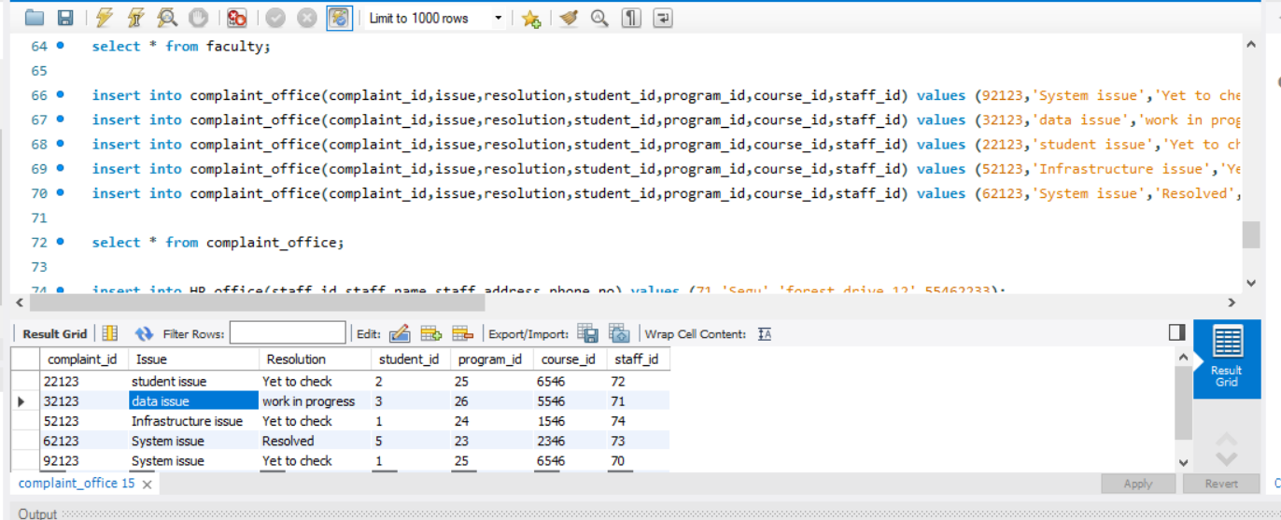

**# Inserting 5 rows of dummy data**  **in the table HR office:**

insert into HR_office(staff_id,staff_name,staff_address,phone_no) values (71,'Segu','forest drive 12',55462233);

insert into HR_office(staff_id,staff_name,staff_address,phone_no) values (70,'arun','chennai 12',43462233);

insert into HR_office(staff_id,staff_name,staff_address,phone_no) values (74,'Hindu','karnataka 12',98462233);

insert into HR_office(staff_id,staff_name,staff_address,phone_no) values (72,'nelson','Rathmines 12',54462233);

insert into HR_office(staff_id,staff_name,staff_address,phone_no) values (73,'wasim','Dubai 12',43462292);

**#Output of the table Complaint office:**

select * from HR_office;

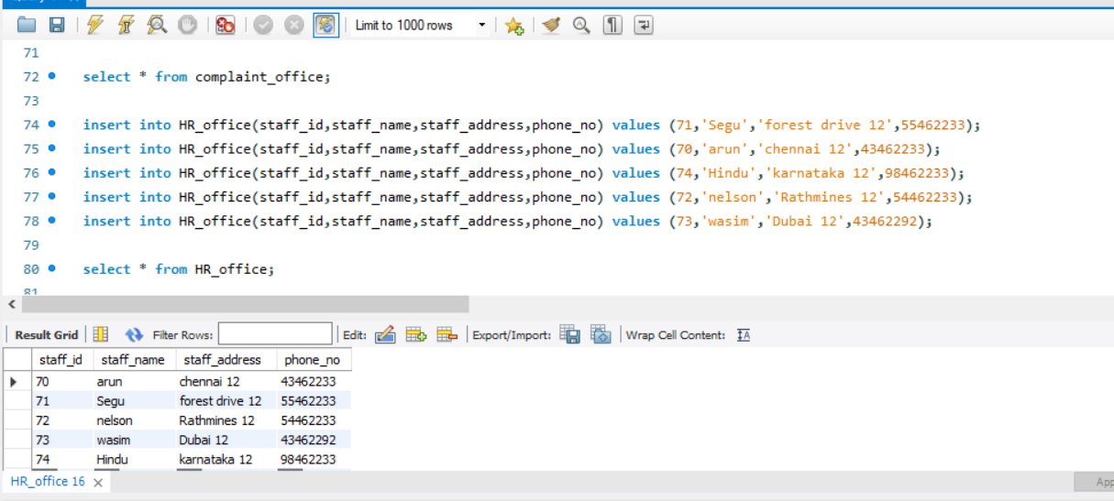

From the Above code we can see that the ER diagram representation of the Database “University” has been converted into a SQL database.

The Entities has been created as a table in the database and the attributes has been inserted in it.

And also 5 rows of dummy variables also have been added in the database.

**Part 2**

**QN1)**

a) Artists with number of albums in descending order:

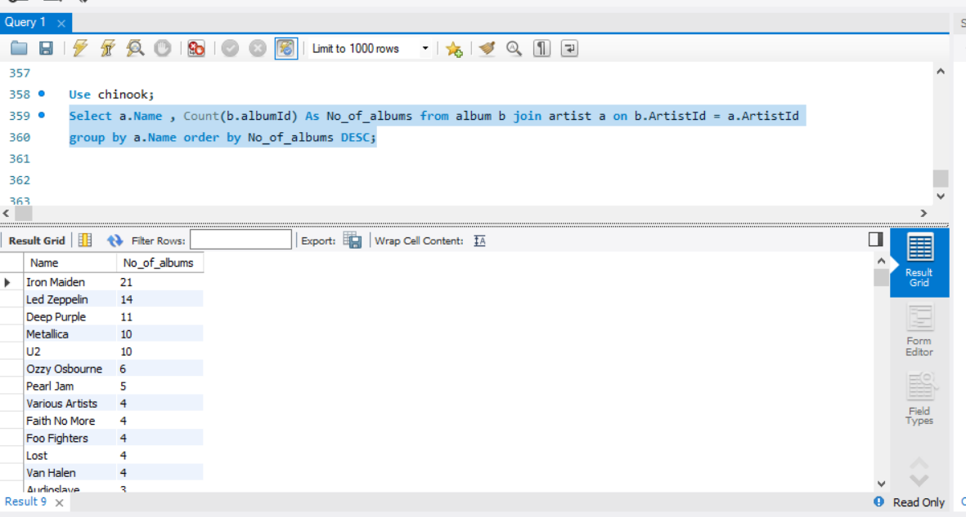

b)

* 1. Name and address of customer with highest total sales across the complete invoice table

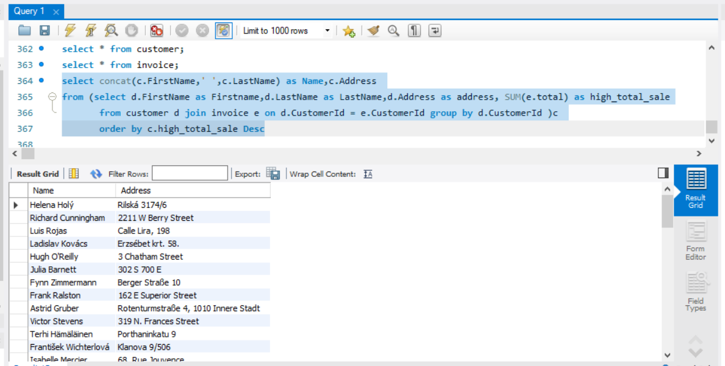

* 1. If need to have only the one customer with the highest total sales across the complete invoice table

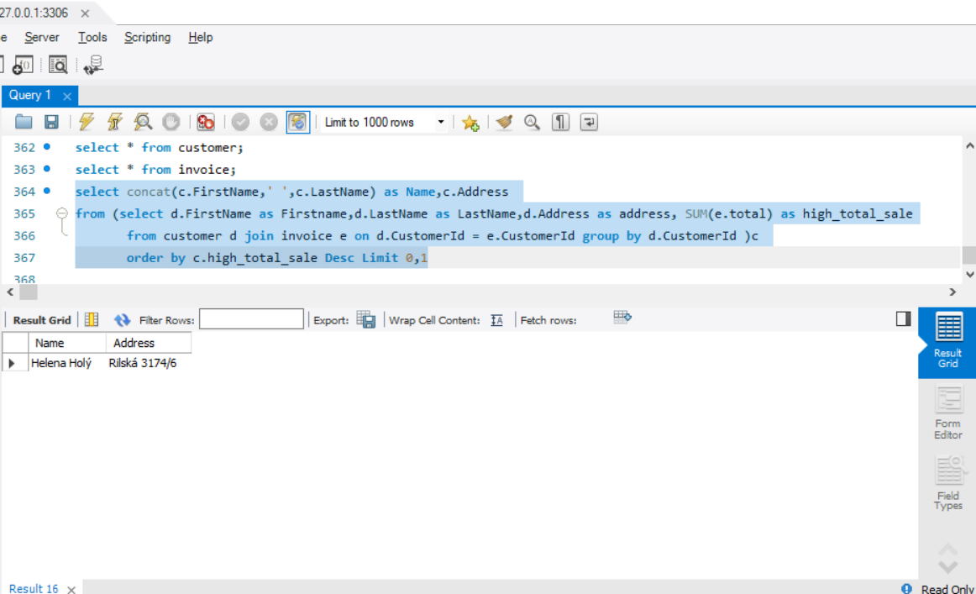

c)

* 1. The name of the tracks that occur most frequently in playlist TV Shows and playlist 90’s music

1. Name of the tracks that occur most frequently in playlist TV Shows:

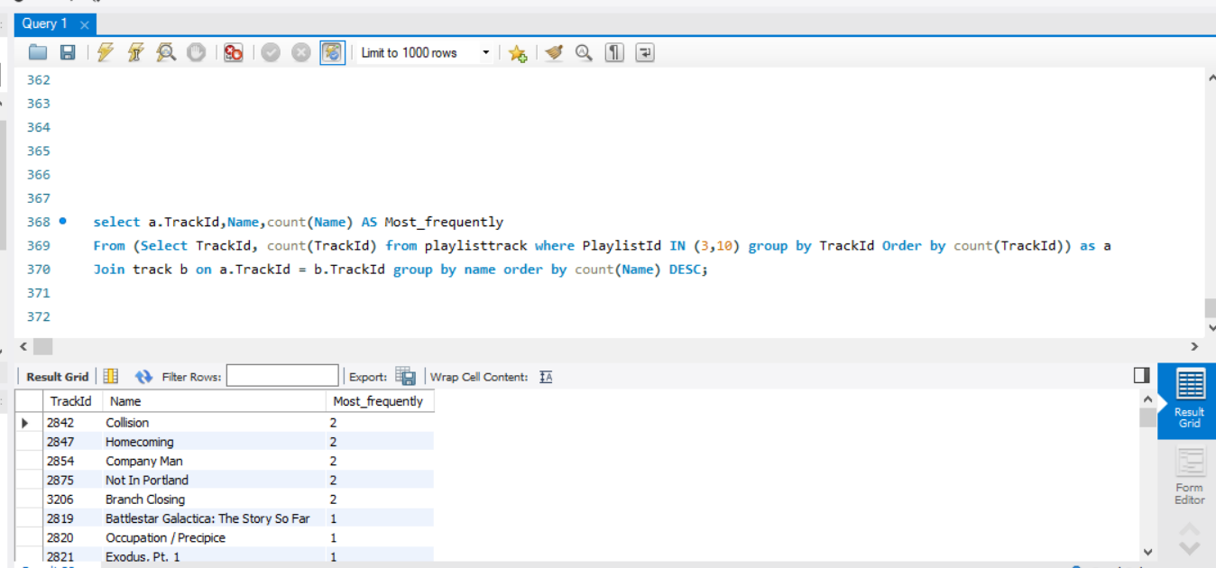

1. Name of the tracks that occur most frequently in playlist 90’s music:

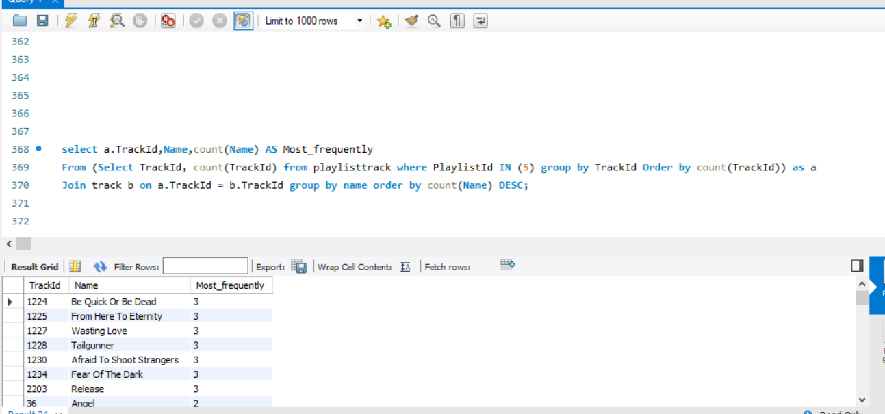

d)

* 1. Name of top 10 tracks by number of times they are present in different playlists i.e., a track is number 1 if it is present in maximum number of playlists

1. 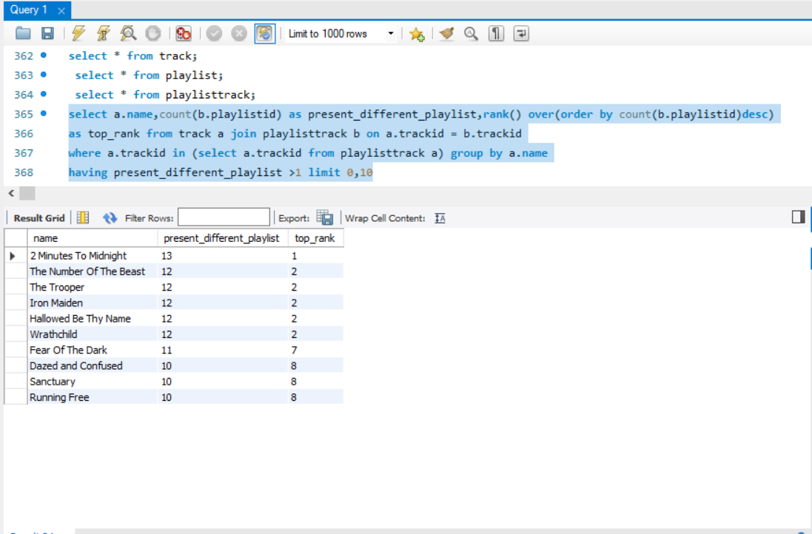

e)

* 1. Countries that the customers belong to with number of customers in each country listed in ascending order
  2. 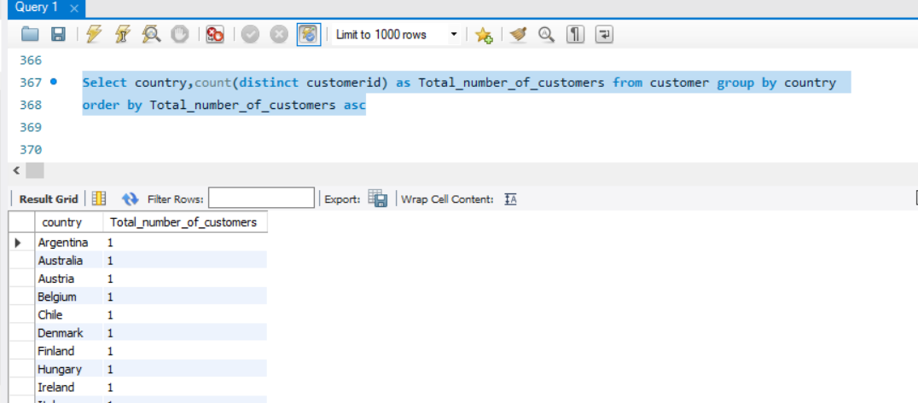

**Qn2)**

1. From the Customer table we could see some of the missing values of customer information like the company, state and the FAX number of the customer and also in the Invoice table there are missing values billingstate column. The customerid is the primary key for the table customer and foreign key in the table invoice.

The missing information of the State of the customer table and billingstate of the invoice table affects . music company for the expand of their operations.

1. In the track table we could find that some of the composer names are missing and also it affects the playlisttrack table since the trackid in the track table is the primary key of track table and its also the foreign key for the playlisttrack and playlist table. So, for some tracks composer names has been missing and some customer tries to buy the albums based on the composer’s name and if it’s missing it affects the music company expansion of their operations.
2. The billingpostalcode is missing for the Portugal and Chile market for some of the customers which in turn affects operation expansion of the music company in Chile and Portugal countries.
3. And from the 1d) code we can find the top 10 tracks which was played frequently in the different playlists, so we can use these top tracks and relate it with the genre of these tracks and recommend to the other customers who uses to listens to the similar genre tracks. So, Recommendation of the tracks can improve the expansion of the music company operations.